**SCHEDULE No. #** **JA44**

**MBBank – Kondor+ Upgrade (Reference ON144176)**

This Schedule Number #JA44 to CONTRACTOR SERVICES AGREEMENT Number #IO07 with effective date 13 September 2018 (the “**Agreement**”) shall become effective upon the date of the latest signature hereto as set out below in the attestation clause (the “**Schedule** **Effective Date**”)

**between**

**Finastra Hong Kong Limited**, whose registered address is Suites 604-610, 6th Floor, Everbright Centre, 108 Gloucester Road, Wanchai, Hong Kong (**“Finastra”**);

**AND**

**Viking Technology Joint Stock Company**, whose registered address is 1002, L10, Thang Long Building, 98 Nguy Nhu Kon Tum, Thanh Xuan District, Hanoi, Vietnam (**“Contractor**”);

(Hereinafter individually referred to as a “**Party**” and collectively as the “**Parties**”).

# 1) This Schedule is a statement of the Services to be provided by the Contractor to Finastra for the benefit of Military Commercial Joint Stock Bank, whose address is 21 Cat Linh, Hanoi, Vietnam (“Client” as referred to in the Agreement or “MBBank”).

# The terms and conditions of the Agreement are deemed incorporated into this Schedule and, together, they shall form an agreement separate from any other in accordance with clause 2.2 of the Agreement.

# This Schedule shall terminate the later of (i) the expiry or termination of the Agreement; or (ii) when Finastra provides written notice that Contractor’s obligations under the Agreement and this Schedule have been fulfilled and accepted.

# The Services will be provided on a fixed-price basis and therefore Part 1 of this Schedule is not applicable.

# For the avoidance of doubt where a conflict arises between the terms and conditions of the Agreement and the provisions of this Schedule then the provisions of this Schedule shall take precedence.

IN WITNESS whereof the Parties have by their duly authorized representatives executed this Schedule as at the dates below written.

|  |  |  |
| --- | --- | --- |
| SIGNED on behalf of FINASTRA and thereby duly authorized: |  | SIGNED on behalf of the CONTRACTOR and thereby duly authorized: |
|  |  |  |
| SIGNATURE |  | SIGNATURE |
|  |  |  |
| FULL NAME |  | FULL NAME |
|  |  |  |
| POSITION |  | POSITION |
|  |  |
| DATE | DATE |

# 

# SCHEDULE – PART 1

**TIME & MATERIAL SERVICES**

Not applicable

**SCHEDULE – PART 2**

**FIXED-PRICE SERVICES**

The following fixed-price Services have been identified and will be provided by the Contractor in accordance with the Statement of Work or Scope of Work provided or to be provided by Finastra:

The Contractor shall provide Services to Finastra for the benefit of its Client in accordance with the Scope of Work attached to this Schedule as Appendix A and Project Plan attached to this Schedule as Appendix B, which include but not limited to the following:

Upgrading the Client’s existing Kondor system version 3.3 and Kondor Global Risk (KGR) system version 3.3 to Fusion Capital Kondor v.3.4.7and Fusion Risk system v.1.7 (or the latest version of the software at the time of signoff of the Statement of Work).

**Standard scope**

* Scope of Software Modules
  + Fusion Capital Kondor Front to Back include MLS (or higher with patches)
  + Fusion Risk (or higher with patches)
  + Distributed Realtime Server (DRT
  + Existing E-Trading
* Scope of Instruments: instruments that is configured and delivered on the Client’s Production Environment will be included in the upgraded system, technical like-to-like upgrade (for the all configuration used in the Client’s existing version) will be included in the upgrade target version
* Scope of Environment
  + 01 Production Environment (existing environment and licensed)
  + 01 Test Environment (existing environment and licensed)
  + 01 DR Environtment (existing environment and licensed)
* Standard Reports: all the existing standard reports will be migrated to Fusion Capital Kondor and Fusion Risk target version. No new reports will be configured additionally.
* Standard Interface: all the existing standard interfaces will be migrated and configured in Fusion Capital Kondor and Fusion Risk Target version and no new Interfaces will be configured.

**Additional Scope**

The scope of the Services is restricted to the modules and functionalities as outlined in to section 2.1 and no new additional modules to be configured in the upgraded system.

* Scope of Customization: existing customization that has been delivered by the Contractor via Implement Schedule ON63041 (BRC No. 0100283873) will be included in upgrade and be tested by Client with Finastra’s consultancy support.
* Non Standard interface: non-Standard interfaces that has been delivered by the Contractor via Implement Schedule ON63041 (BRC No. 0100283873) will be tested by the Client with with Finastra’s consultancy support to ensure existing interface can be continue running in target upgrade version.
* Non-Standard Report: existing non-standard reports that has been delivered by the Contractor via Implement Schedule ON63041 (BRC No. 0100283873) will be included in upgrade and be tested by the Client with Finastra’s consultancy support.

Out of Scope: any item not specified in the preceding paragraphs 2.1 and 2.2 is specifically excluded from the scope of Services to be provided by the Contractor.

**Fixed Price Fees**

* **USD118,000.00** (inclusive of charges and taxes)

**Travel Cost and Expenses**

Travel cost and expenses are included as part of the Fixed Price Fees. The Services under this Schedule will be performed by the Contractor in Hanoi, Vietnam, either on site or off site, where necessary and required.

**Enhancement requests**

The Parties agree that, where a change/enhancement request is raised by the Client, it shall be considered by the business design authority for approval. If approved, it will be presented to the change control board for agreement and prioritization. Following this, the Parties agree that for requests needed to meet functional requirements agreed between Finastra and the Client as a specific requirement for the Client, then the Client shall bear the cost of this development effort.

**Invoicing and Payment**

Finastra shall pay the Contractor the Fixed Price Fees in instalments upon completion of each of the project phases as detailed in section A.3 (DELIVERABLES BY PROJECT STAGES) of Appendix A (“**Project Phases**”) according to the following payment plan:

* 20% of the Fixed Price Fees shall be payable upon the completion of the Initiate stage in accordance with the Project Phases;
* 20% of the Fixed Price Fees shall be payable upon the completion of the Define stage in accordance with the Project Phases;
* 25% of the Fixed Price Fees shall be payable upon the completion of the Build stage in accordance with the Project Phases; and
* 35% of the Fixed Price Fees shall be payable upon the completion of the Test, Deploy and Close stages in accordance with the Project Phases.

Invoices shall be due for payment 30 days after receipt of invoices subject to receipt of corresponding payments from the Client by Finastra pursuant to the Work Order ON144176 between Finastra and the Client.

**SCHEDULE – PART 3**

**CLIENT PROVISIONS and PROJECT ASSUMPTIONS**

All of the pricing and expenditure assumptions set out in this Schedule are based on the assumption that the following are made available by the Client in the context of the project and produced on either its own authority or by means of third-party suppliers.

**Technical facilities**

1. Provision of the entire hardware, operating system and standard software, and other infrastructure, which is necessary for the operation of the overall Client solution.
2. In addition to the Production Environment a test environment will be made ready by the Client in which the Company and its partners can work.
3. All interfaces to third-party systems will be provided including documentation.
4. If applicable, delivery and rendering available of the data on the third party systems for the interfacing to the System Product by the Client or third party suppliers.
5. Adaptation of the interfaces by third party suppliers (insofar as necessary).
6. Operating the systems.
7. Installation of the operating and other system software.
8. Configuration of the hardware.

**Business Provisions**

1. Testing concepts, test cases, test data, and testing activities.
2. Provision of an internal project manager.
3. Provision of banking business and technical contacts.
4. Premises for the project team with corresponding equipment and provision of the necessary resources.
5. Business preparation and organization.
6. Authorization concepts and realization.
7. Cooperation of the concerned Client departments in any System Product implementation.
8. Participation in the migration concepts and realization.
9. Preparation and carrying out of Acceptance.

**Software**

As Required

**SCHEDULE – PART 4**

**CHANGE CONTROL PROCEDURE (“CCP”)**

1. **Change Requests**

A change request may be raised during the term of this Schedule where either Finastra or Contractor sees the need for a change to the Schedule, the Specifications, project plan, and/or any other document describing the Services and System Product to be provided (“**Baseline Documents**”). Either Party may at any time request a change to the Baseline Documents in accordance with this CCP. Change requests must be made in writing using a Finastra prescribed change request form - as attached as Appendix C to this Schedule.

1. **Generating the Change Request**

Where the need for a change to the Baseline Documents has been identified, a change request will be generated to contain the following: -

* 1. the title of the change;
  2. the originator and date of the request or recommendation for the change;
  3. the reason for the change;
  4. details of the change including (without limit) any Specification; and
  5. proposed implementation date or revised project plan, as applicable.

1. **Responding to the Change Request**

In responding to a change request from Finastra or included within a change request proposed by Contractor, Contractor shall deliver to Finastra a change proposal containing:-

* 1. the price and charges, if any, of the change;
  2. details of the impact on Services, System Product and Specification, as applicable;
  3. details of the impact on the hardware and software environment, the location, as applicable;
  4. a timetable for implementation; and
  5. a schedule of payments as appropriate.

Contractor shall where reasonably practicable deliver its change proposal within ten (10) days of receipt of a Finastra change request. Finastra where reasonably practicable will respond to a change proposal from Contractor within ten (10) days of receipt thereof.

1. **Finastra’s Options**

Upon receipt of Contractor’s change proposal, Finastra may elect to either:

* 1. Accept such proposal by counter-signing the proposal, in which case the Baseline Documents shall be amended accordingly; or
  2. Reject the change proposal, in which case the Baseline Documents shall continue in force

unchanged.

Neither Party shall be obliged to perform or be bound by any change until a written change proposal is signed by the authorized representatives of both Parties.

**SCHEDULE – PART 5**

APPENDIX A: SCOPE OF WORK - DELIVERABLES BY PROJECT STAGES

APPENDIX B: PROJECT PLAN

**APPENDIX A – SCOPE OF WORK** - **DELIVERABLES BY PROJECT STAGES**

The project is structured in the following sequence of phases (the “**Project Phases**”), the activities which Finastra, the Contractor and the Client will perform and the deliverables which the Contractor will deliver within the scope of this SOW (the “**Deliverables**”) are listed under the Project Phases in which they are associated.

Under the responsibility matrix below when Finastra, Contractor or Client are responsible for:

Executing the activity, it will be marked as “E”

Supporting the execution of service, it will be marked as “S”

Participating in an activity, it will be marked as “P”

Reviewing and accepting the Service/Deliverable, it will be marked as “A”

A brief description of each of these responsibilities can be found below:

Execute (E) – means to perform or to carry out what is required by the Project Plan. The Party assigned to E will lead and perform the work.

Support (S) - means that the Party acting as Supporter will have a secondary or subordinate role to the other Party who is the lead performer. Although it is a secondary role to the lead performer, it is nevertheless an active role. Supporter role is also when the other Party is assigned an E role.

Participate (P) – Participation is mainly used in conjunction with knowledge transfer tasks, mainly on training. In this case, the Party required to participate will be present during the activities, but not providing the training.

Review and Accept (A) – The formal examination of a Deliverable by the Party designated to perform such review. Promptly following the performance of each review, the applicable Deliverable must either be accepted or be returned to the Executing Party with a consolidated list of comments and/or observations, to allow such Executing Party to promptly clarify or address issues that the Party performing the review has with the Deliverable so that such Deliverable will be ready to be used in the next step of the Project.

**A.2.1. Initiate stage deliverables**

|  |  |  |  |  |  |  |
| --- | --- | --- | --- | --- | --- | --- |
| ID | Activity Name | Activity Description | Deliverables | Deliverable Type | Viking | Company/ Client |
| I001 | Procure hardware and 3rd party software(if any) | Purchase recommended hardware and third-party software as per the pre-requisites provided by the Company – as specified in the documentation of the Software | ID001 Hardware and other 3rd party software components | Equipment | S | E |
| I002 | Conduct Project Kick-off Meeting | Formally start the Project after the Company and Client teams review and produce the Project Plan. | ID002 Signed Project Plan | Document | S | E |
| I003 | Deliver Finastra Software | Deliver software licenses and Standard User document | ID003 Signed SW delivery acceptance note | Installation | S | E |

Gate 1: Planning Complete

*Client formal approvals/ exit gates:*

Gate 1.1. Signed Software Delivery

Gate 1.2. Accept Project Plan

**A.2.2. Define stage deliverables**

|  |  |  |  |  |  |  |
| --- | --- | --- | --- | --- | --- | --- |
| ID | Activity Name | Activity Description | Deliverables | Deliverable Type | Viking | Company/ Client |
| D001 | Setup upgrade Environment | Setup the environment:   * 3rd party software will be installed by Client * Install MS SQL Server DB and Product components (Listed in Section 2.1.1) by Company | D001 Dev / Test Environment Ready | Configuration | E | A |
| D002 | Pilot Upgrade | Pilot Upgrade on Test environment   * Upgrade existing Konor version to FusionCapital Kondor target version * Upgrade existing KGR version to Fusion Risk target version * Install and configure Distributed Realtime Server(DRT) | D002 Test Environment with Upgrade Version | Configuration | E | A |
| D003 | Set up Existing Version Environment | Setup Existing Kondor/KGR version Environment for Data Comparison |  |  | E | A |
| D004 | **Pilot Upgrade Data Verification** | **Post Upgrade Data Comparison between existing version and upgrade version:**   * **Kondor Standard Financial Report** * **Kondor Standard Cash Flow Report** * **Fusion Risk Standard Limit Report** | **D003**  **Pilot Upgrade Data Verification Report** | **Document** | **E** | **S** |
| D005 | What ‘s New Training | Conduct What’s New Training for both Fusion Capital Kondor and Fusion Risk 2 session in both Kondor and Fusion RIsk   * Training is for users and IT personnel who will perform the testing. | D004 | Training Material | S | E |
| D006 | **Interfaces, Custom Windows and Custom Reports** | **Standard / Non-Standard**   * **Interfaces** * **Custom Windows** * **Custom Reports**   **that is configured and delivered as part of Implement Schedule ON63041 (BRC No. 0100283873) on the Client’s Production Environment will be included in the like for like upgrade** | **D005 Test Environment with Upgrade Version like for like with existing Interfaces / Custom Windows / Custom Reports** | **Configuration** | **E** | **S** |

Gate 2: Environment setup Complete

*Client formal approvals/ exit gates:*

Gate 2.1. Inform Client the Gate 2 completion

Gate 2.2 Complete What’s new refresh Training

**A.2.3. Build stage deliverables**

|  |  |  |  |  |  |  |
| --- | --- | --- | --- | --- | --- | --- |
| ID | Activity Name | Activity Description | Deliverables | Deliverable Type | Viking | Company/ Client |
| B001 | Develop UAT Scope Document | Client will define the UAT scope (as expressed by the set of test scenarios and cases), process and acceptance criteria | BD001 UAT Scope Document | Document | S | E |
| B002 | Produce Test Scenarios and Cases | Client will produce test cases and scenarios which form the basis of the testing and acceptance criteria. | BD002 Test scenarios and cases | Document | S | E |
| B004 | Migration Plan | Discuss with Client for data migration plan | BD004 Data migration plan | Document | E | S |
| B005 | Perform Pre-UAT Test | Company will test the Solution based on the selected set of test cases defined by the Client and/or Company to ensure the configured Solution is performing as specified. Results will be documented. | BD005 Documented pre-UAT test results | Document | E | A |

Gate 3: Configuration Complete

*Client formal approvals/ exit gates:*

Gate 3.1 Agreed UAT Scope (including test cases)

Gate 3.2 Pre-UAT Completion

**A.2.4. Test stage deliverables**

|  |  |  |  |  |  |  |
| --- | --- | --- | --- | --- | --- | --- |
| ID | Activity Name | Activity Description | Deliverables | Deliverable Type | Viking | Company/ Client |
| T001 | Deliver Solution ready for UAT | Deliver a solution build ready for User Acceptance Testing | TD001 System ready for UAT | Configuration | E | S |
| T002 | Finalize UAT plan and checklist | Client will establish final location, schedule and responsibilities for UAT and ensure UAT readiness checklists are complete. | TD002 UAT Plan | Document | S | E |
| T003 | Train users for UAT | * Training is for users and IT personnel who will perform the testing. * If training is for more participants, additional instructors will be required to meet the quality training standards. Any subsequent additional training will be paid by the Client including the training fees and travel/transportation, visa and accommodation and living expenses of the second instructor. The same will apply if additional training lessons are required by the Client. | TD003 Trained Attendance | Workshop | S | E |
| T004 | Set up UAT Environment | * Prepare UAT Environment by installing final application model configuration of the Solution. * Prepare Real-time Data Feed connection for UAT Environment | TD006 UAT Environment Ready | System | E | S |
| T005 | Perform System Integration test/User Acceptance Testing (UAT) | Support the client through testing to ensure that the configured Solution is performing as specified. Client will test the system as per defined test plan and test cases. | TD004  Issue Log | Document | E |  |
| T006 | Apply UAT Fixes and Retest | Company will apply changes/fixes required  Client will be retesting failed scenarios to ensure meeting agreed exit criteria | TD004 Issue log  TD007 UAT Sign Off | Document | E  S | S  E |
| T007 | Update Business procedures & processes | Client to document updated business procedures & processes, if any. | TD008 Operations Manual | Document | S | E |
| T008 | Perform Mock Conversion | Company to assist Client in Mock Conversion. Main Client activities:   * Execute Cutover plan * Validate converted data on upgraded system. * End User Review and Approval * Capture and resolve Issues * Finalize cutover plan | TD011 Mock Conversion Testing Report | Document | S,E | E, A |

Gate 4: Testing Complete

*Client formal approvals/ exit gates:*

Gate 4.1 Signed UAT Plan

Gate 4.2 Signed Testing Completion

Gate 4.3 Signed Mock Conversion Report

**A.2.5. Deploy stage deliverables**

|  |  |  |  |  |  |  |
| --- | --- | --- | --- | --- | --- | --- |
| ID | Activity Name | Activity Description | Deliverables | Deliverable Type | Viking | Company/ Client |
| DE001 | Install Final System Build and Set-up the production environment | Install Final System Build and Set-up the production environment | DE001 Production Environment | Configuration | E | S |
| DE002 | Finalize Cutover Plan, including Resources and Go-Live Checklist | Client and Company will build a detailed list of activities and procedures for Conversion and “Go-Live” | DE002 Final Cutover Plan | Document | E | E |
| DE003 | Collate technical handover system documentation | Client and Company will finalise technical documentation of the network, architecture, operations procedures etc. | DE003 Technical Site Document | Document | E | E |
| DE004 | Execute Cutover Plan | The Client and Company will execute the final production cutover plan. The Company will provide consultancy support: assist Client in conversion during the go-live weekend and for the rollout activities. | DE004 Live System | Configuration | E | E, A |
| DE005 | Provide post-live support | Without prejudice to the Company’s obligations to provide Maintenance Services in accordance with the Framework Terms, the Company will provide post Go-Live support | DE005 Issue & Risk Log | Document | S | E |

Gate 5: Go-Live Complete

*Client formal approvals/ exit gates:*

Gate 5.1. Agreed Final Cutover Plan

Gate 5.2. Signed Go-Live

Gate 5.3. Completed Post Go-Live Support

**A.2.6. Close stage deliverables**

|  |  |  |  |  |  |  |
| --- | --- | --- | --- | --- | --- | --- |
| ID | Activity Name | Activity Description | Deliverables | Deliverable Type | Viking | Company/ Client |
| C001 | Handover to CS | Company will introduce Customer Support team to client and handover any outstanding issues to CS. | C001 Outstanding Issues Log  and  C002 GS to CS Checklist | Document | S | E |
| C002 | Close Project | Company and Client will confirm that all deliverables have been completed and will produce a closing project report that will include a snapshot of the outstanding issue log. | C003 Project Closure Report | Document | E | E |

Gate 6: Project Complete

*Client formal approvals/ exit gates:*

* Gate 6.1. Completed Customer Services Handover
* Gate 6.2. Signed Project Closure Report

**APPENDIX B – PROJECT PLAN**

Below high-level project has not yet factor the public holiday, the final project plan will be mutually agreed within 4~6 weeks after the Work Order is signed. The total project duration is estimated around 6~7 months.

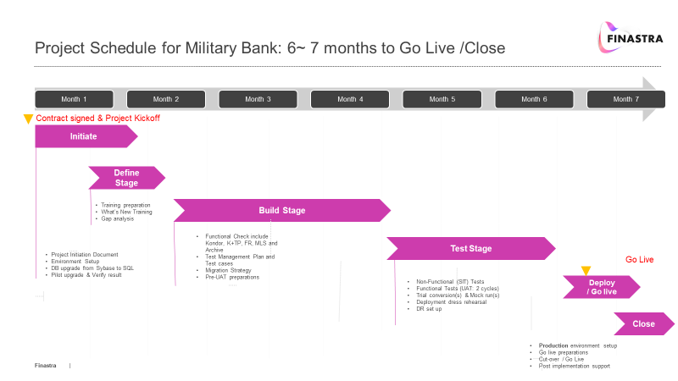

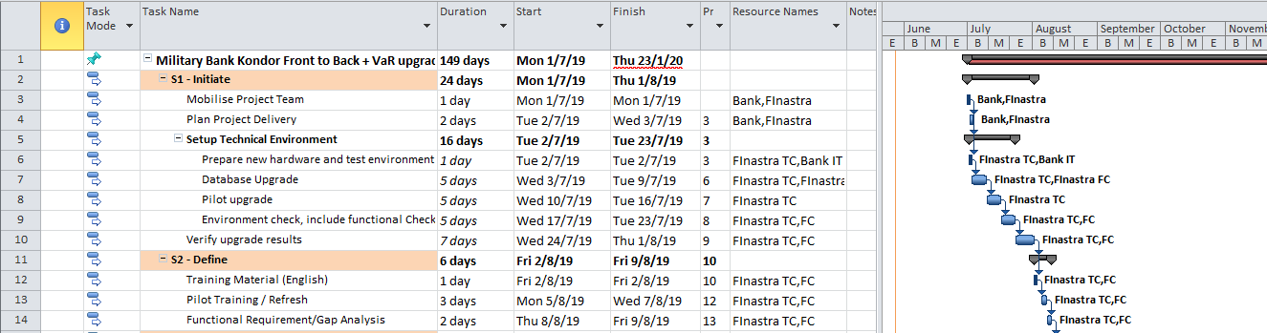

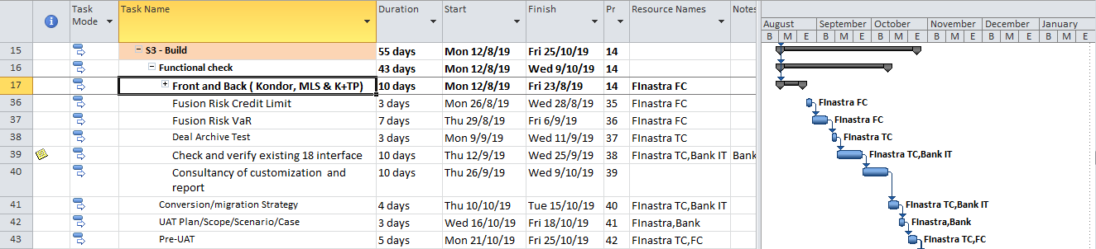

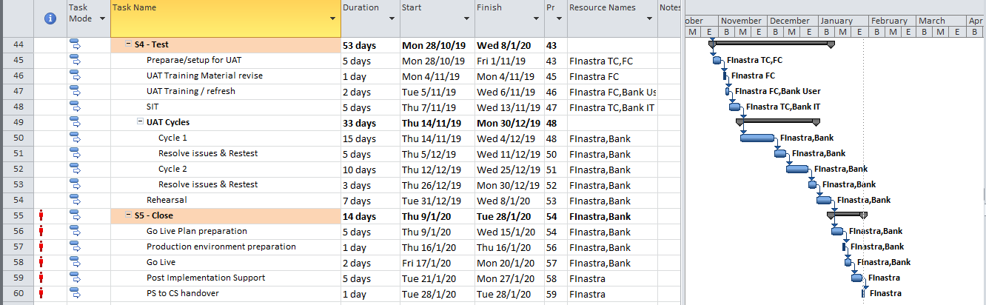

**APPENDIX C – CHANGE REQUEST FORM**

|  |  |  |  |  |  |  |  |  |  |  |  |  |  |  |  |  |  |  |  |  |  |  |
| --- | --- | --- | --- | --- | --- | --- | --- | --- | --- | --- | --- | --- | --- | --- | --- | --- | --- | --- | --- | --- | --- | --- |
| **Bank Name:** | | | | | **Project Name:** | | | | | | | | | | | | | | | | | |
| **Prepared by:** | | | | | **Date:** | | | | | | | | | **Original SOW/Contract #:** | | | | | | | | |
| **Section I. To be Completed by Originator** | | | | | | | | | | | | | | **SOW Change #:** | | | | | | | | |
| **1. Change Description (summary):** | | | | | | | | | | | | | | | | | | | | | | |
| **2. Change Justification:** | | | | | | | | | | | | | | | | | | | | | | |
| **3. Change Type:** | |  | **Requirements** | | | | | |  | | **Design** | | | |  | **Development** | | | |  | | **Documentation** |
|  | |  | **Interfaces** | | | | | | | | | | | |  | **Communications Services** | | | | | | |
| **4. Change Category** | |  | **Enhancement** | | | | | |  | **Rework** | | | | |  | **Other (explain):** | | | | | | |
| **5. Change Priority (Check One):** | |  | Optional | | | | | |  | Desirable | | | | |  | Mandatory | | | | | | |
| **Section II. To be Completed by Vendor Project Manager** | | | | | | | | | | | | | | | | | | | | | | |
| **1. Related Change Requests (list [s]):** | | | | 2. Estimated Start Date | | | | | | | | | | | | | | 3. Estimated End Date: | | | | |
| **4. Estimated Effort (Days):** | **6. Change Description (Detailed):** | | | | | | | | | | | | | | | | | | | | | |
| 5. Estimated Cost: | 7. Project Impact: | | | | | | | | | | | | | | | | | | | | | |
| Schedule Impact: | | | | | | | Budget Impact: | | | | | | | | | | Scope Impact: | | | | |
| **Section III. Final Approval Signatures and Funding** | | | | | | | | | | | | | | | | | | | | | | |
| **Approval (Check One):** | | | | | |  | **Approved** | | | | |  | **Not Approved** | | | |  | | **Defer Until :** | | | |
| **First Client Authorized Name (Print):** | | | | | | **Signature** | | | | | | | | | | | | | | | **Date:** | |
| **Second Client Authorized Name (Print):** | | | | | | **Signature** | | | | | | | | | | | | | | | **Date:** | |
| **2. Vendor Authorized Name (Print):** | | | | | | **Signature** | | | | | | | | | | | | | | | **Date:** | |